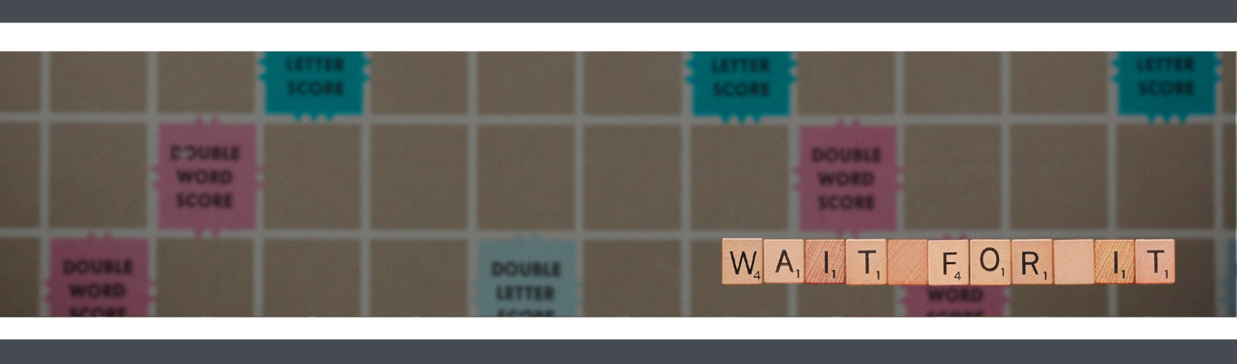
WEEK 2
PRESCHOOL LESSON GUIDE

THE BIG IDEA
Wait and see, the Savior will change everything.

THE BIBLE
John Tells People About Jesus: John 1:19-28

WELCOME TIME

INTRO ACTIVITY | Changing Colors
- INSTRUCTIONS: Give each kid a scratch art ornament and a stylus. Have them decorate it however they'd like but point out how the colors change with each stroke. Pro tip: Use double-sided tape to secure the ornament so that it doesn't move too much while the kids try to decorate.
  - TODDLER HACK: Use color with water activity books or Crayola Color Wonder kits to show how color appears even though you can't see it on the tips of the brush or marker.
- Notice how all the colors changed while you were decorating? Maybe you really wanted one part of your ornament to stay in one color, but the paper changed the color on you!
- Things don't always work out the way we wish they did. We don't always get everything we want. But when plans change on us, we have to remember that if God is in charge, those changes are so much better than what we were thinking.
- Look at all your ornaments! You see . . . change can be beautiful!
Wait and see, the Savior will change everything.

MUSIC | Worship
- INSTRUCTIONS: Prepare to lead the kids into a fun time of worship with songs

TEACHING TIME

VIDEO | Wait For It, Episode 2
- INSTRUCTIONS: Play this week's preschool teaching video.

SCRIPTURE | John 1:19-28
- INSTRUCTIONS: Explain the different motions you’d like the kids to do while they listen to the story. Tell them to shrug their shoulders every time the Jewish people are confused about John the Baptist, shake their heads “No” every time John tells them that he is not the Savior, and put their thumbs up whenever John tells them about the Savior.
- Our story this week begins where we left off last week. Last week, we heard all about a special man named John the Baptist, who was preparing the way for Jesus the Savior by telling people all about Jesus and baptizing the people in water.
- Because John was telling everyone around him about the Savior and baptizing them, the Jewish leaders sent people called the Levites to ask John who he was (Shrug your shoulders). John explained to the Levites that he was not the Savior (Shake your head), but a messenger.
- John told them he was making way for the Savior (Put your thumbs up). But the Pharisees and the Levites were still confused (Shrug your shoulders). They asked why he was baptizing people if he was not the Savior.
- John told them when he baptized people with water, he didn't really wash away their sin – he just helped people decide in their hearts to ask God for forgiveness. But the Savior could actually wash away our sins (Put your thumbs up)! John said that the Savior was coming and they should all be ready to receive his message (Put your thumbs up).

THE BIG IDEA | Wait and see, the Savior will change everything.
- INSTRUCTIONS: Use the giant dice from last week and encourage the kids to take turns passing and rolling the dice. When they roll two of the same number, they get to uncover the Big Idea! Then, ask all of the kids to say the Big Idea together.
- Now for one more roll, everyone give me a drumroll!
- Today's Big Idea is . . . Wait and see, the Savior will change everything.

DISCUSSION TIME

ACTIVITY | Worth the Wait
- Can you think of something that changes into something completely different over time? The first thing I thought of was a caterpillar!
- INSTRUCTIONS: Give each kid a handful of pompoms, half a pipe cleaner, and a clothespin. Have kids glue pompoms on one side of the clothespin. Open the pin and insert the pipe cleaner, forming the antenna. Then give kids a small piece of colored gift tissue and have them pinch the paper in half to form a butterfly (Check out the pictures here).
- You see how your caterpillar became a butterfly! In real life, a caterpillar takes about nine to fourteen days to become a butterfly. And when it becomes a butterfly, it looks almost completely different than what it looked like as a caterpillar. And it can even fly now!
- Sometimes change happens very slowly and it's easy to get impatient. But God reminds us that waiting for our Savior, Jesus, is worth the wait. When Jesus came to earth, everything was better. That's the message John the Baptist was telling everyone – wait and see, the Savior will change everything.

ACTIVITY | Ready Prayer One
- INSTRUCTIONS: Prepare copies of handouts that have a virtual reality (VR) headset printed on them. Have kids draw a picture of something they might have to wait a while for . . . like what they might be when they grow up.
- What is something you pray you might have or see in the future?
- We can pray to God and God hears us and answers us. But sometimes God wants us to wait until the right time.
- That's what God did with Jesus – God sent the Savior at just the right time to change the world forever!
- Wait and see, the Savior will change everything.

POLL | Do You Wish You Could Change?
- INSTRUCTIONS: Line up all of the kids on one side of the room. As you ask the questions, instruct the kids to take one step forward if their answer is yes and to stay where they are if their answer is no.
  - TODDLER HACK: Prepare a twinkle light necklace kids can take turns wearing (or provide one for each kid). As they look at the lights changing color, ask them if they like when the lights change or when they stay the same.
- Do you wish you could change . . .
  - how old you are?
  - how tall you are?
  - how many brothers and sisters you have?
  - where you live?
  - your hair color?

MEMORY VERSE | Micah 7:7 (NIV)
“But as for me, I watch in hope for the Lord, I wait for God my Savior; my God will hear me.” Micah 7:7
- Our memory verse today is super important! To help us remember, we’re going to hopscotch and dance our way through the hopscotch board!
- INSTRUCTIONS: Create a hopscotch pattern on the floor by arranging the pages of the memory verse printable in a hopscotch pattern. Reinforce the papers with clear packing tape so they won't rip as kids hop over them. Have kids read the words of each box that they hop to. At the end of the hopscotch, tell the kids to make up a fun dance and dance to the back of the line. Play some upbeat music while the kids do this activity.
  - TODDLER HACK: Arrange the memory verse pages in a straight line and space them out. Have kids form a line behind you. Hop to the first box and say the words in that box. Have kids copy you. Keep going until you get to the end of the verse.

PRAYER
- Dear God, sometimes we might not like change because it makes us give up something we are used to. But remind us that when it's Jesus making the change, the change is always good. Thank you for changing everything. Amen.

PLAY TIME

While you’re waiting for parents to pick up their kids . . .

ACTIVITY | Coloring Page
- INSTRUCTIONS: Provide this week's coloring page and some crayons or markers. Review today's Bible story and Big Idea as the kids color.

Encourage your preschoolers to help clean up the room while they wait for their parents.

