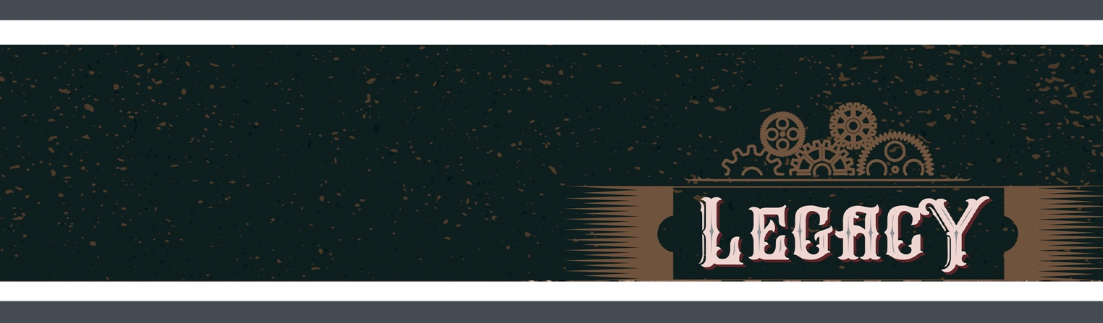
WEEK 5
PRESCHOOL Activities

THE BIG IDEA
The Holy Spirit makes us a part of God's family.

THE BIBLE
Life in the Spirit: Romans 8:12-17

SNACK | Divine Design
- All month long, our series has been called, "Legacy." The Holy Spirit is the legacy that Jesus gives us.
- Not only that, but God has given us people — parents, grandparents, cousins, aunts and uncles, teachers, and other people who show us how to be God's child.
- Let's show how thankful we are for those people by making our cookies look like one of them!
- INSTRUCTIONS: Lay out large sheets of either homemade or pre-cut gingerbread-shaped cookies. Allow the kids to decorate the cookies with icing, sprinkles, etc.

ACTIVITY | Families Forgive
- INSTRUCTIONS: Divide the kids into pairs. Go outside with chalk and encourage the kids to trace each other's bodies on the sidewalk or pavement (if indoors, use pieces of painter's tape). Encourage the kids to share with each other some bad choices they made recently. Get a water hose and spray away the chalk (or rip off the tape).
- The Holy Spirit lets us know when we do something wrong and need to ask God to forgive us. Then God does! God washes away our sins like the water washed away the chalk (or we took out the tape from the floor).
- God does this for us because we are in God's family. The Holy Spirit makes us a part of God's family!

ACTIVITY | Coloring Page
- INSTRUCTIONS: Provide this week's coloring page and some crayons or markers. Review today's Bible story and Big Idea as the kids color.

MEMORY VERSE | Romans 8:14 (NIV)

“For those who are led by the Spirit of God are the children of God.” Romans 8:14

- INSTRUCTIONS: Give kids a copy of the Memory Verse printable and have them color in the words in the order of the memory verse. Call out the words or write out the words on pieces of paper to show and help them find the correct words.

PRAYER
- Dear God, thank you for the legacy you gave to us . . . the Holy Spirit. Thank you for making us a part of your family. Thank you, Holy Spirit, for showing us how to live like members of God's family. Amen.

